GPR Root Mapping System

Team 24

Final (Progress) Report

ECEN 403 – Capstone (Senior) Design Project

Texas A&M University, College Station, TX

Tyler Castro

Coy Coburn

Daniel Miller

Michael Turner

**Abstract**

This document focuses on the project overview and each of the subsystems (transmitting/receiving antenna) involved in the ground penetrating radar root mapping system. The transmitting antenna incorporates pulse compression by generating chirps, this in turn creates a linearly frequency modulated signal. This signal is passed to the data processing side for phase matching and to the phased array antennas. The phased array antennas will directionally aim the signal into the ground for better penetration depth and resolution. The receiving antenna will pick up the resulting echoes created from the transmitter antenna’s signal colliding into an object as well as the ground itself, and reflected back. These reflections will be processed and amplified for digital conversion. These resulting digital signals will be processed into images for the display.

**Table of Contents**

**Abstract**

**Table of Contents**

**1 Project Overview**

1.1 Current System Design

1.2 Project Deliverables

1.3 Definition of Interfaces

1.4 Task Ownership

**2 Individual Contributions Transmitting Antenna**

2.1 Significant Changes in Direction

2.2 Subsystem Status

2.3 Subsystem Challenges and Solutions

2.4 Subsystem Technical Details

2.5 Subsystem Testing

**3 Individual Contributions <Subsystem #2 Name>**

3.1 Significant Changes in Direction

3.2 Subsystem Status

3.3 Subsystem Challenges and Solutions

3.4 Subsystem Technical Details

3.5 Subsystem Testing

**4 Conclusions**

**References**

# Project Overview

The GPR root mapping systems will locate plant roots underground using radar waves emitted and received by arrays of antennas. Mathematical equations will be applied to the reflected signal so the user can interpret the data. Geophysicists can use this data to examine plant root growth over a period of time.

## Current System Design

The transmitting antenna consists of a chirp generator, power splitter and amplifier, and a phased antenna array. The transmitting circuit must be able to generate a signal powerful enough so the receiving antennas can collect the attenuated signal.

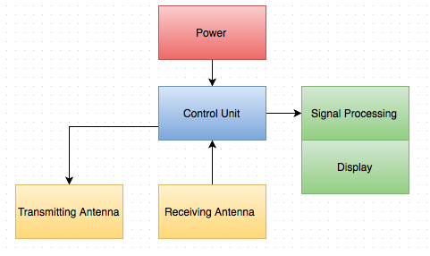

Figure 1.1: System block diagram.

## Project Deliverables

By the end of the semester, we plan to have a working radar system able to detect objects 1 meter deep in sand. Due to the complexity of most of the components and the time required to procure them ourselves, all components will be purchased online.

### Subsystem Specifications

The transmitting antenna should generate a chirp with a desired voltage and current of 400mV and 4.5 mA.

This will provide a power of 675mW at each of the four antennas.

Table 1.1  
Subsystem Specification Compliance Matrix

|  |  |  |  |
| --- | --- | --- | --- |
| Specification | Min | Nominal | Max |
| Chirp Power |  |  |  |
| Power Amplifier Gain | TBD |  |  |
| Antenna Power |  |  |  |

### System Specifications

The TVG in the receiver subsystem should amplify the reflections based on the time received by the antenna, with an initial gain of 1 dB.

Table 1.2  
System Specification Compliance Matrix

|  |  |  |  |
| --- | --- | --- | --- |
| Specification | Min | Nominal | Max |
|  |  |  |  |
| TVG amplification | TBD |  |  |
| Antenna Power |  |  |  |

## Definition of Interfaces

Table 1.3  
Responsibility Matrix

|  |  |  |
| --- | --- | --- |
| Subsystem | Responsible Member | Responsibilities |
|  |  |  |
| Transmitting Antenna | Tyler Castro  Daniel Miller | Implementation of chirps  Design of phase array antennas |
|  |  |  |
| Receiving Antenna | Coy Coburn  Michael Turner | Reflection amplification  Design of receiving phase array antenna  Analog to digital conversion |

## Task Ownership

Tyler Castro and Daniel Miller are responsible for the transmitting antenna. This includes researching initial design and testing, as well as its physical construction and choice of components. In particular, they will need to decide on chirp values, pulse compression, and the design of the phased array antenna.

Table 1.4  
Responsibility Matrix

|  |  |  |
| --- | --- | --- |
| Subsystem | Responsible Member | Responsibilities |
| Transmitting Antenna | Tyler Castro  Daniel Miller | Full design and testing for transmitting antenna includes:  Generating chirp for pulse compression  Signal splitter for phase matching for receiving antennas  Power amplification  Design of phased array antenna  Power calculations |
| Receiving Antenna | Coy Coburn  Michael Turner | Full design and testing for receiving antenna includes:  Time varying gain compensation for incoming reflections  Signal mixer for incoming signal transmissions  Low noise amplification  Design of phased array receiver antenna  Image procession |
|  |  |  |
|  |  |  |

# Individual Contributions Transmitting Antenna

The transmitting antenna section generates a linear chirp with an average frequency of 915 MHz with duration of 1.25 ns. These pulses will be sent through a power amplifier to be emitted by an array of four antennas. The original pulse will also be sent straight to the receiving end of the system by a power splitter for the purpose of mixing for pulse compression. All four antennas will have a phase shifter immediately before it, in order to aim and focus the pulse.

## Significant Changes in Direction

N/A

## Subsystem Status

Currently, the voltage and current of the generated chirp in the simulation is +/-400 mV and +/-4.5 mA. The power amplifier serves to increase the power of the signal to allow it to travel through the ground without attenuation completely destroying it. The power amplifier has a gain of 17 dB. The power currently at one antenna is 675mW, and the minimum required power to have the waves reach the receivers is 1W.

Table 2.1  
<Subsystem> Specification Compliance Matrix

|  |  |  |  |
| --- | --- | --- | --- |
| Specification | Min | Nominal | Max |
| Power from Source  Power Amplifier Gain  Power at Antennas (Individually) | TBD |  |  |
|  |  |  |  |
|  |  |  |  |

## Subsystem Challenges and Solutions

The biggest challenge presented in this subsystem was reaching the proper power level in order to overcome the ground attenuation. Our solution was to add phase shifters to concentrate the wave at a specific point. Proper tuning of the phase shifters allow for maximum constructive interference at a point.

## Subsystem Technical Details

The chirp generator consists of two pulse generators in series, which create a series of linear ramps separated by a set amount of time. That function is fed into a voltage-controlled oscillator, making the generated pulses modulated linearly. Next is the splitter and power amplifier in series. The splitter sends the original pulse to the receiving end for mixing, and the power amplifier provides the gain required for the pulse to travel through the ground. The antenna array consists of a 1-4 power splitter, which leads to four separate antennas, all equipped with their own phase shifter.

Below is two tables showing values obtained during testing of the power amplifier and the voltage controlled oscillator.

Table 2.2   
Power Amplifier

|  |  |  |
| --- | --- | --- |
| Parameter | Specification | Simulation Results |
| Gain | 11dB | 11dB |
| Bandwidth | 915MHz | 915MHz |
|  |  |  |

Table 2.2   
Voltage Controlled Oscillator

|  |  |  |
| --- | --- | --- |
| Parameter | Specification | Simulation Results |
| Kv | 914 MHz | 914 MHz |
| Frequency at 0 V | 0 Hz | 0 Hz |
|  |  |  |

## Subsystem Testing

Simulating the transmitting antenna circuit in Advanced Design System was the only testing we were able to perform on the subsystem so far.

### ADS Simulation

The ADS simulation’s purpose was to confirm our architecture, as well as see the gain and loss throughout the system.

#### Test Setup

The schematic for the transmission circuit was replicated in Advanced Design System, as shown below.

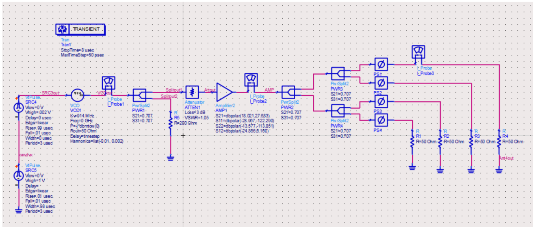

#### Figure 2.1: Transmitting block diagram

#### Data

The graphs below show the linear modulation of frequency in the generated chirps, as well as the separation of each individual chirp.

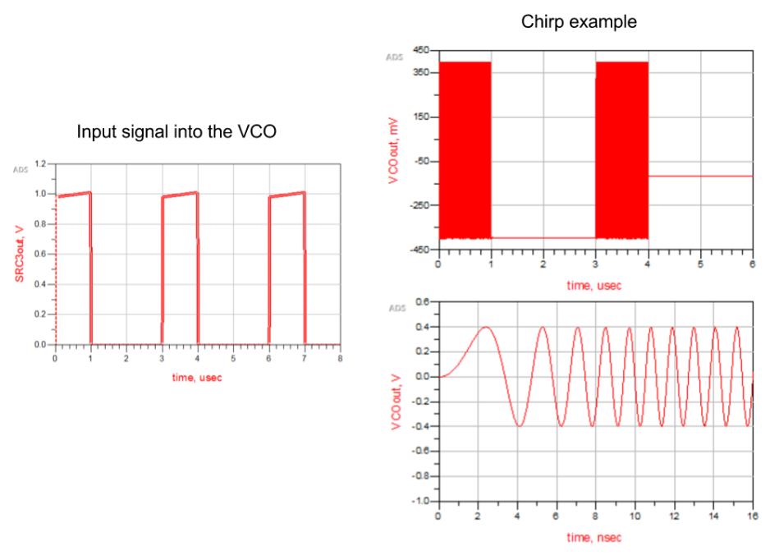

*Figure 2.2: Signals produced throughout system*

#### Conclusion

The subsystem correctly generated chirps, but the VCO used in the simulation has a set voltage, and is unable to change. Therefore, the proper power required at the antenna was unable to be reached. An improvement to the system above will be to incorporate a 1-4 power splitter instead of the cascading 1-2 power splitters as depicted in Figure 2.1 above. This will decrease the power loss between the generated signal and the signal passed to the antennas.

# Individual Contributions Receiver Antenna

The receiving antenna will be composed of a phased array of 4 antennas to pick up the reflections transmitted. These will be amplified in proportion to the time received by the TVG, and mixed to create a complete picture of the reflections found in the range of the LNA. This signal will be converted into a digital form, which will be utilized in processing the image illustrated by the reflections that were received.

## Significant Changes in Direction

Initial circuit system included a flow from the phased array antenna to the LNA, TVG, mixer, and ADC for image processing. However, in research of prior GPR projects, the team decided to instead have the phased array connect to the TVG then the LNA, then to the mixer and digital converter. This is due to the idea that the GPR’s objective is to detect and present a picture of all the objects in the ground hidden to the user. The LNA will increase its sensitivity to incoming noise in this implementation, up to 96 dB.

## Subsystem Status

The subsystem currently takes in a simulated GPR receiver signal and passes it through a TVG and a LNA. The signal is simulated from a pulsed decaying sine wave of round 10 mV. The TVGs gain curve is a linear line increasing with time. The LNA has a Noise Figure of about 1.2 dB.

## Subsystem Challenges and Solutions

While the ADS testing showed positive results for a simple 1 antenna receiver system, the team still needs to implement the phased array system. The 2 main choices are between a homodyne and heterodyne implementation. While heterodyne would yield higher quality results, the team is choosing to implement the homodyne version due to the much lower cost. The heterodyne system also utilizes a local oscillator for each receiver signal circuit path, which could add unnecessary complexity.

## Subsystem Technical Details

The receiving antenna array consists of 4 receiver antennas that are each connected to their own subcircuit. This section expects incoming reflections that originate from the transmitter antenna. Once picked up by the phased array receiver antenna, the signal will be passed through a time varying gain amplifier. This is to compensate for loss of gain in the reflected signal. The signal then passes through a low noise amplifier system for another amplification so to notice any possible reflection. These processed signals will then pass through a mixer to sum the reflections found via autocorrelation. This final signal is converted from analog to digital and its values utilized for image processing. The antenna array consists of 4 receiver antennas that are each connected to a TVG followed by a LNA system. These are later mixed and sent to the ADC for conversion and image processing.

Below is two tables showing values obtained during testing of the time varying gain circuit and the low noise amplifier.

Table 3.2   
Time Varying Gain

|  |  |  |
| --- | --- | --- |
| Parameter | Specification | Simulation Results |
| Gain | 1dB | 0.9 - 10.5 dB |
| Bandwidth | 915MHz | 915MHz |
|  |  |  |

Table 3.2   
Low Noise Amplifier

|  |  |  |
| --- | --- | --- |
| Parameter | Specification | Simulation Results |
| Gain | 2dB | 2.15dB |
| Bandwidth  Noise Figure | 915MHz  1 - 1.5 dB | 915MHz  1.2 dB |
|  |  |  |

## Subsystem Testing

Simulating the receiving antenna circuit in Advanced Design System was the only testing we were able to perform on the subsystem so far.

### ADS Simulation

The ADS simulation’s purpose was to confirm our architecture.

#### Test Setup

The schematic for the receiver circuit was replicated in Advanced Design System, as shown on the next page.

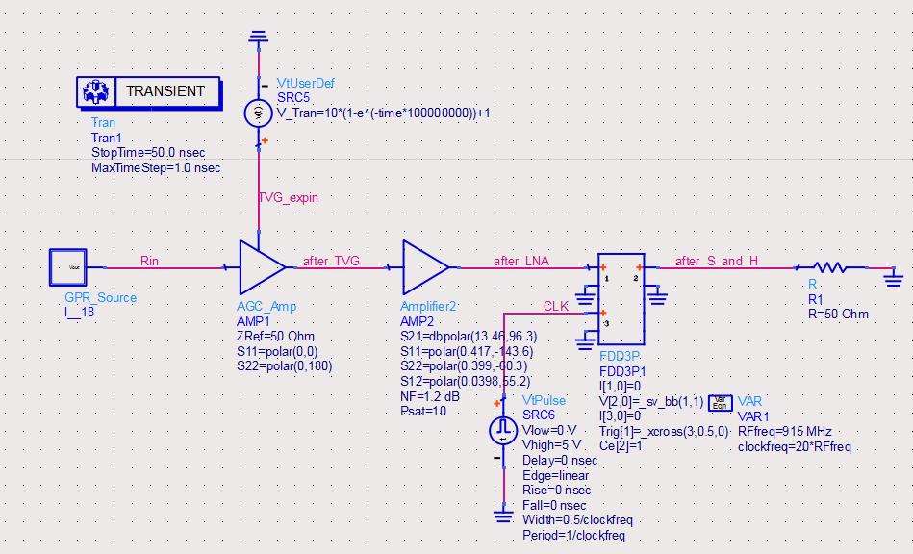

#### Figure 3.1: Receiver block diagram

The input signal was a pulsed decaying sine wave to simulate a signal that the GRP receiver might receive.

* + - 1. 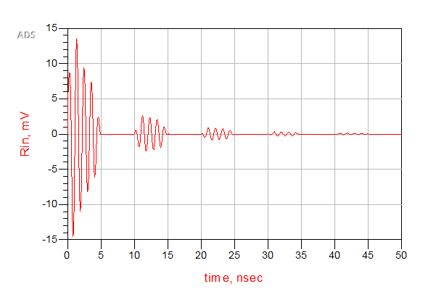

#### Figure 3.2: Receiver input diagram

#### Data

The graphs below show the signal after it passes through the TVG and LNA

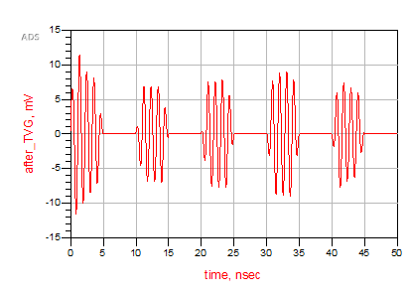

*Figure 3.3: Signals produced by TVG*

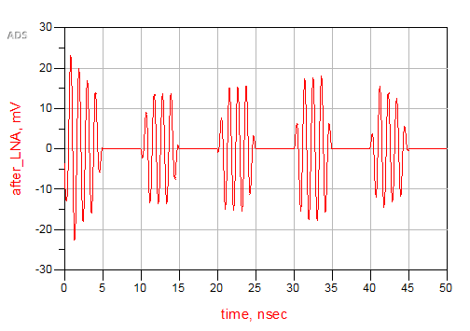

*Figure 3.4: Signals produced by LNA*

#### 

#### Conclusion

The subsystem correctly applied a time varying gain to the received signal and increased the gain of the overall signal. The final design will have to be a homodyne phase array receiver, so the subsystem will need to be redesigned for this case.

# Conclusions

Explain the main significance of this document. What does the information presented mean and why is it important? What is the current status of the entire project, what are the major results. New results should not be introduced in this section although recommendations for future improvements may be considered.

**References**

[1] Christian Wolff, “Phased Array Antenna ,” [Online]. Available at: http://www.radartutorial.eu/06.antennas/Phased%20Array%20Antenna.en.html. [Accessed: 2015]

[2] Cedric Martel, “Modelling and Design of Antennas for Ground-Penetrating Radar Systems ,” Ph.D. dissertation, Dept. Elect. Eng, Univ. of Surrey, Guildford, United Kingdom, 2002.

[3] “Ground Penetrating RADAR (GPR) (After Basson 2000) Introduction,” GPR theory, 2007. [Online]. Available at: http://www.geo-sense.com/gprmore.htm. [Accessed: Jan-2015].

[4] *Standard Guide for Using the Surface Ground Penetrating Radar Method for Subsurface Investigation*, Active Standard ASTM D6432, 2011

[5] A. P. Annan, "Ground Penetrating Radar Principles, Procedures & Applications," Sensors & software Inc., Mississauga, Ontario, 2003

[6] Bart Scheers, “Ultra-Wideband Ground Penetrating Radar, with Application to the Detection of Anti Personnel Landmines,” Ph.D. dissertation, Dept. Elect. Eng, Catholic Univ. of Louvain, Louvain-la-Neuve, Belgium, 2001.

[7] C. Allen , “Radar Pulse Compression ,” 2004. [Online]. Available at: https://www.ittc.ku.edu/workshops/Summer2004Lectures/Radar_Pulse_Compression.pdf. [Accessed: 2015]

[8] Cedric Martel, “Modelling and Design of Antennas for Ground-Penetrating Radar Systems ,” Ph.D. dissertation, Dept. Elect. Eng, Univ. of Surrey, Guildford, United Kingdom, 2002.

[9] “Ground Penetrating RADAR (GPR) (After Basson 2000) Introduction,” GPR theory, 2007. [Online]. Available at: http://www.geo-sense.com/gprmore.htm. [Accessed: Jan-2015].

[10] Standard Guide for Using the Surface Ground Penetrating Radar Method for Subsurface Investigation, Active Standard ASTM D6432, 2011

[11] A. P. Annan, "Ground Penetrating Radar Principles, Procedures & Applications," Sensors & software Inc., Mississauga, Ontario, 2003

[12] Bart Scheers, “Ultra-Wideband Ground Penetrating Radar, with Application to the Detection of Anti Personnel Landmines,” Ph.D. dissertation, Dept. Elect. Eng, Catholic Univ. of Louvain, Louvain-la-Neuve, Belgium, 2001.